Chem 302 Laboratory 2

Numerically Solving The Schrodinger Equation for

Particle In A Box

NAME:

The Schrodinger equation for a particle in a box is:

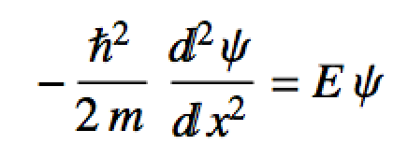

1. Identify the kinetic energy and potential energy operators.

2. Using the **Numerov.functions.R** and **Numerov_control.R** scripts, initialize the correct potential and solve this differential equation for a box of length 1.5 length units. Do this for the ground and fourth excited states. Upload picts the graphs of the wave functions you obtain. Also input the eigenvalues you obtained from the program.

3. Describe an algorithm that you could use to normalize the solutions you obtained above. Write out a reasonable “pseudo-code”.

4. Assume the length of the box is *L*. What is the *analytical result* for the normalization constant? What variable does the normalization constant for particle in a box depend on?

5. Use **Numerov.functions.R** and **Numerov_control.R** functionality to numerically normalize the wave functions you obtained. Plot the corresponding *normalized* probability density curves. Input the most likely positions to find the particle. (***DO NOT SUBSTITUTE THE PLOT FROM*** the approx.normalize function! Use the output contained in Npsi.info and the plot() function to make your normalized density pictures. Upload the picts.